Intrinsic Optical Signal Imaging Trial Instruction Manual

BMEG CAPSTONE 2024-2025

Client: Dr. Bridi, Rockefeller Neuroscience Institute

Dr. Anika Pirkey: [Anika Pirkey - arcoolbaugh@mix.wvu.edu](mailto:arcoolbaugh@mix.wvu.edu)

Jada Mullins

Hunter Jackson

Lauren Musbach

Riley Nett

**Installation guide of ISI system adjusted from the Haider Lab – Georgia Tech**

**List of equipment**

| **# ID** | **Equipment name** | **# of Items Vendor Cat. No. / Comments** |
| --- | --- | --- |
| **1** | Primary Computer (Monitor) |  |
| **2** | Secondary Computer  (Laptop) |  |
| **3** | CMOS camera | 1 ThorLabs CS165MU SN: 22632 |
| **4** | Arduino Uno Rev3 | 1 Arduino Bar: 7630049200487 |
| **5** | Emission filter  (525-nm bandpass filter) | 1 Edmund Optics 87-801 |
| **6** | Emission filter  (700-nm bandpass filter) | 1 Edmund Optics 88-018 |
| **7** | Lens 1 | 1 Nikon AI-S FX Nikkor 50 mm f/2 manual  focus lens |
| **8** | Lens 2 | 1 Nikon |
| **9** | Camera mount | 1 ThorLabs |
| **10** | Macro Focusing Rail | 1 NiSi Model #: NM-180S |
| **11** | Polymer Sheet | 2 |
| **12** | Base Breadboard | 1 ThorLabs |
| **13** | Neopixel Ring 24 x 5050 RBG LED with Integrated Driver | 1 Adafruit 1586 |
| **14** | T-Rail |  |
| **15** | L bracket |  |
| **16** | Adjustable Rigid Stand | 1 ThorLabs MP100-MLSH |
| **17** | Screws 1 |  |

**System setup**

**Primary computer** [Windows 10 – Intel Core i7 Processor – 32 GB RAM]: This is the main processing unit of the system. It instructs the secondary computer to start visual stimulus display [4], controls the light intensity [1], triggers the camera [2], acquires analog signal from photodiode [3].

**Secondary computer** [Windows 10 – Intel Core i7 Processor – 48 GB RAM]: Displays visual stimulus on monitors after primary computer gives instructions via UDP connection.

**Equipment setup**

1. Download the *Novice* or *Advanced* ISI package from the Haider Lab GitHub (Link: https://github.com/haiderlab/ISI/ )

2. Install Psychotoolbox on secondary computer, which is used for stimulus presentation. Check for specifications here: http://psychtoolbox.org/requirements/

3. Place photodiode on bottom right corner of secondary computer screen and connect it to DAQ (item #3 in above schematic).

4. Connect the DAQ to primary computer. If the DAQ used is from Measurement computing (MC), the driver must be installed in Matlab. See section below for how to install MC DAQ in Matlab. 5. Insert frame-grabber in primary computer. It must be placed in a PCI slot.

6. Assemble camera, lenses, and emission filter wheel. (The wheel should be placed between the two lenses.

a. Top lens must be focused at ∞ to 2.8

b. Bottom lens must be focused at ∞ to 5.6

7. Connect camera to frame-grabber.

8. Assemble light source and connect to primary computer.

**How to install MC DAQ driver in Matlab (**Version R2018b)

1. Download MC driver package from Matlab (Home -> Add-Ons -> Get Hardware Support Packages).

2. Install Measurement computing (MC) DAQ drivers from the provided disc. The latter is provided with the device by the manufacturer.

3. Close Matlab, and start InstaCall (This step is critical!). InstaCall is a software provided with the DAQ. It is part of the drivers installed during step 2. Once InstaCall is open, follow the steps below.

a. Find your device in platform

b. Start acquisition of signal

4. Close InstaCall and start Matlab again.

**How to run an experiment**

Note:

1. We offer novice and advanced software for running the hardware and getting signals. The novice version allows to quickly record using default parameters. The advanced version allows to enter/change visual stimulus parameters.

2. Some of these steps may be specific to our setup. Adjustments may be necessary.

**I. Novice version**

**Case 1: Imaging the mouse after craniotomies**

1. Turn on the camera:

- Plug in the power cord to the wall outlet

- Blue light will be emitted on top of camera, then turn green

- wait for at least 1 min after plugging the camera

2. Turn on the Illumination:

- Only flip the bottom right power switch

3. Uncap the camera lens

- Make sure the bottom lens is focused at **∞ to 2.8**

- Make sure the top lens is focused at **∞ to 5.6**

4. On the secondary (slave) computer:

- Turn on MATLAB as an administrator

- Add path (location of software package)

- Open “**secondary_script.m”**

- Enter IP address of primary computer

- Run the script

|  |
| --- |

5. On the primary (master) computer:

- Turn on MATLAB as an administrator

- Add path (location of software package)

- Open “**primary_script.m**”

- Set **cameraInterface.useExecutable** equal to **false**

- Enter the mouse ID at **inputM.mouseID**

- Enter the date at **inputM.date**

- Enter the input session at **inputM.ses**

**-** Enter IP address of secondary computer

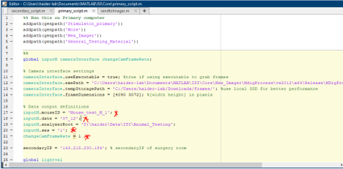** **Place the mouse under camera**

**\*\* Using a Caliper, measure the length of the cranial window edges. This is important to determine the real size of areas**

**\*\* Injecting Sedative: Following the sedative preparation**

**- The max volume given to animal is (weight[g]/100) mL**

**I.e. If the weight of mouse is 20 g, the max V of sedative you can inject is 0.2 mL**

**However, we usually give half of the maximum allowed**

6. Run the primary script

- An adjust list window will appear

**- CLOSE that window!**

|  |
| --- |

7. A new window GUI will appear

- Click on **Launch live**

- Click on **Capture image**

- On the captured image on the right, select the cranial window by clicking and dragging - Click on **View ROI**

- Click **Azimuth** in “Stimulus direction” panel

- Click **No** in “Both directions” (**DO CLICK even if already selected!**)

- Write **1** under “# Block (10 sweeps/block)”

- Click **Run**

**\* This is it. A feedback window will appear signifying that process is done.** See example 2 below. **\* You may repeat step 1 - 7 with cranial window in 3 states: 1) With Saline; 2) Right after remove saline (AKA moist cranio); 3) With dry cranio**

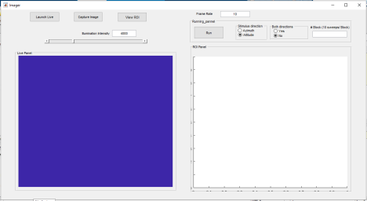

**Case 2: Imaging for retinotopic maps**

* If the Camera is already powered, and the Frame rate has been changed then continue below * If the Camera is off, you must power it then do Case 3 FIRST before continuing to Case 2

1. Turn on the Illumination:

- Only flip the bottom right power switch

2. Uncap the camera lens

- Make sure the bottom lens is focused at **∞ to 2.8**

- Make sure the top lens is focused at **∞ to 5.6**

3. On the secondary (slave) computer:

- Turn on MATLAB as an administrator

- Add path (location of software package)

- Open “**secondary_script.m”**

- Enter IP address of primary computer

- Run the script

|  |
| --- |

4. On the primary (master) computer:

- Turn on MATLAB as an administrator

- Add path (location of software package)

- Open “**primary_script.m**”

- Set **cameraInterface.useExecutable** equal to **true**

- Enter the mouse ID at **inputM.mouseID**

- Enter the date at **inputM.date**

- Enter the input session at **inputM.ses**

**-** Enter IP address of secondary computer

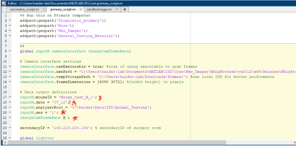** **Place the mouse under camera**

**\*\* Using a Caliper, measure the length of the cranial window edges. This is important to determine the real size of areas**

**\*\* Injecting Sedative: Following the sedative preparation**

**- The max volume given to animal is (weight[g]/100) mL**

**I.e. If the weight of mouse is 20 g, the max V of sedative you can inject is 0.2 mL However, we usually give half of the maximum allowed**

6. Run the primary script

- An adjust list window will appear

**- DO NOT CLOSE IT! SEE BELOW FOR NEXT STEP**

|  |
| --- |

7. Click the home button and open **Matrox Intellicam**

8. In **Matrox Intellicam**, click on the folder icon found in upper left side

- The purpose is to download the DCF file for camera interfacing

9. In the opened window, go to: **cam_DCF**

- Select: Final_DCF.dcf

10. Select the icon named **Continuous Grab** next to the folder icon

** **Put the green filter in the illumination box**

**\*\* Turn the revolver between lenses to green filter**

11. Now you should be connected to the camera

- Zoom out a bit until the camera field is about half the window

- Move the camera until the cranio is visible & the brightest light beam is at the center of the cranial window

- Adjust the light using the Matlab window opened in step 6

- Focus until blood vessels are visible (then focus slightly below vessels (~100 - 500 uM below) | vessels will appear slightly blurry when zoomed in. Doing so increases your ability to detect robust signals. However, omitting this step is usually fine)

** **Close Matrox Intellicam**

12. Go back to MATLAB, and close the adjust light window

**\* Let’s image blood vessels**

13. A new window GUI will appear

- Click on **Launch live**

- Click on **Capture image**

- On the captured image on the right, select the cranial window by clicking and dragging - Click on **View ROI**

- Click **Azimuth** in “Stimulus direction” panel

- Click **No** in “Both directions” (**DO CLICK even if already selected!**)

- Write **1** under “# Block (10 sweeps/block)”

- Click **Run**

* This is it. A feedback window will appear signifying that process is done.



14. NO NEED to close MATLAB

- Close the feedback window

- Change the light filter to red in the light box

- Rotate the wheel between the camera lenses so that red light can pass **without moving the camera**

15. Run the primary script

16. Close the “Adjust Light” window

17. A new window GUI will appear

- Click on **Launch live**

- Click on **Capture image**

- On the captured image on the right, select the cranial window by clicking and dragging - Click on **View ROI**

- Click **Azimuth or Altitude** in “Stimulus direction” panel

- Click **Yes** in “Both directions” (**DO CLICK even if already selected!**)

- Write **how blocks you want displayed** under “# Block (10 sweeps/block)”

* For example, if you enter **2**, the azimuth stimulus will sweep 2 times in Left-Right, then 2 times in Right-Left.

* I suggest you enter 5 here

- Click **Run**

* This is it. A feedback window will appear signifying that process is done. See example 2 below. 18. Repeat step 15 - 17 until you have the number of desired “repeats” in Azimuth or Altitude

**Case 3: How do I change the frame rate of the Camera ?**

1. Power/Plug the camera

2. Click the home button and open **Matrox Intellicam**

3. In **Matrox Intellicam**, click on the folder icon found in upper left side - The purpose is to download the DCF file for camera interfacing

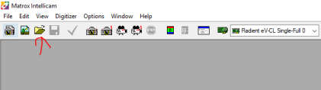4. In the opened window, go to: **cam_DCF**

- Select: Final_DCF.dcf

5. Click on “Feature Browser”

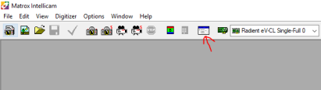

6. Click on “GenCP_01_00” & Click OK

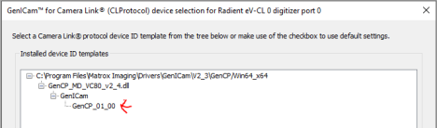

7. Select “Teledyne DALSA” → “Sensor Control” (See example below)

8. In “Frame Rate” section enter 10.0 then press **ENTER**

9. OPTIONAL: You can run “Grab continuous” in Matrox Intellicam and look at the bottom right to see that the camera operates at ~10.0 fps

10. Close Matrox Intellicam

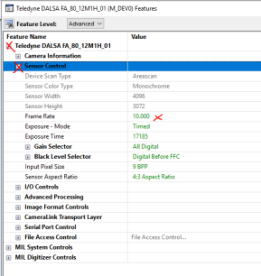

**II. Advanced version**

1. Turn on the camera:

- Plug in the power cord to the wall outlet

- Blue light will be emitted on top of camera, then turn green - wait for at least 1 min after plugging the camera

2. Turn on the Illumination:

- Only flip the bottom right power switch

3. Uncap the camera lens

- Make sure the bottom lens is focused at **∞ to 2.8**

- Make sure the top lens is focused at **∞ to 5.6**

**\*\* Reset the camera frame rate by following “Case 3” in the Novice *version*.** 6. On the secondary (slave) computer:

- Turn on MATLAB as an administrator

- Add path (location of software package)

- Open “**secondary_script.m”**

**-** Enter IP address of primary computer

- Run the above script

|  |
| --- |

7. From the Secondary computer, Remote Desktop to the primary computer OR go to the primary computer if it is connected to a screen.

**\*\* Move to “Camera reset Frame rate”** section below (after step 32) before continuing

8. On the primary (master) computer:

- Turn on MATLAB as an administrator

- Add path (location of software package)

- Open “**primary_script.m**”

- Enter the mouse ID at **inputM.mouseID**

- Enter the date at **inputM.date**

- Enter the input session at **inputM.ses**

**-** Enter IP address of secondary computer



** **Place the mouse under camera**

**\*\* Using a Caliper, measure the length of the cranial window edges. This is important to determine the real size of areas**

**\*\* Injecting Sedative: Following the sedative preparation**

**- The max volume given to animal is (weight[g]/100) mL**

**I.e. If the weight of mouse is 20 g, the max V of sedative you can inject is 0.2 mL However, we usually give half of the maximum allowed**

9. Run the primary script

- An adjust list window will appear

**- DO NOT CLOSE IT! SEE BELOW FOR NEXT STEP**

|  |
| --- |

10. Click the home button and open **Matrox Intellicam**

11. In **Matrox Intellicam**, click on the folder icon found in upper left side

- The purpose is to download the DCF file for camera interfacing

12. In the opened window, go to: **cam_DCF**

- Select: Final_DCF.dcf

13. Select the icon named **Continuous Grab** next to the folder icon

** **Put the green filter in the illumination box**

**\*\* Turn the revolver between lenses to green filter**

14. Now you should be connected to the camera

- Zoom out a bit until the camera field is about half the window

- Move the camera until the cranio is visible

- Adjust the light using the Matlab window opened in step 9

- Focus until blood vessels are visible (then focus slightly below vessels (~100 - 500 uM below) | vessels will appear slightly blurry when zoomed in. Doing so increases your ability to detect robust signals. However, omitting this step is usually fine)

** **Close Matrox Intellicam**

15. Go back to MATLAB, and close the adjust light window

16. A new window GUI will appear

- Click on **Launch live**

- Click on **Capture image**

- On the captured image on the right, select the cranio by clicking and dragging - Click on **View ROI**

- Set Frame rate to **10**

|  |
| --- |

17. Close that window

18. 3 window GUIs will appear: **Main**, **Looper**, **ParamSelect**

- Spread the GUIs around

19. On the **looper** GUI

- In the first box, under “**symbol**”, write: **ori**

- In the second box, under “**vector**”, write: **[0]**

|  |
| --- |

20. In the **ParamSelect** GUI

- Click on **Load** and Go to:

**Advanced\Params**

- Select **horizontal.param**

|  |
| --- |

21. In the main window, click **Run**

22. Wait until visual stimulus has stopped being shown

- The black screen will appear again, but this time with the right frame rate: 10 frames/sec

|  |
| --- |

23. A feedback window will appear displaying (with Blood dynamics)

* If the response is satisfactory proceed below

* If the response is not satisfactory, you may intervene by adjusting light intensity, camera focus, or anesthesia level and re-run with green light

24. Change the light filter in Box to allow **RED** light, and filter b/w lenses to allow **RED** light

25. Close/open MATLAB, and repeat step 8

26. Run the script

- This time quickly close the Adjust light

**DO NOT BRING Matrox Intellicam**

27. Follow steps 16, **However**

- After clicking **Launch Live**, you must **Adjust the light** using the slider

28. Repeat Steps 17-21, **However**

**-** On the second box of the first row in **looper**, write:

**- [0 180]** for **Azimuth** recording

**- [270 90]** for **Elevation** recording

- When loading in **Param Select**

**-** Select **horizontal.param** for **Azimuth** recording

- Select **vertical.param** for **Elevation** recording

29. After the feedback appears **ONLY :**

- Change **ori** bracket in Looper

- Load appropriate file into **ParamSelect**

** DO NOT CLOSE MATLAB ANYMORE UNTIL YOU’RE DONE WITH ALL Recordings 30. REMEMBER TO:

1) Write notes/description of recordings in folder

2) Unplug camera & switch off illumination box

31. If you want to switch from **New** Camera interface to **Old**, write **false** in line 11 in the primary script 32. Shut down computers and anesthesia & unplug the camera before leaving.

**How to process phase maps after frame acquisition**

1. Download the *Post-Recording* ISI package from the Haider Lab GitHub

(Link: https://github.com/haiderlab/ISI/ )

2. Follow instructions in run_first.m for processing of phase and visual field sign maps 3. Follow instructions in Align.m for aligning retinotopic maps to craniotomies.

Examples